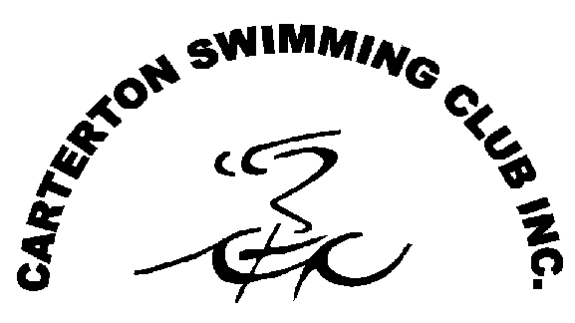

**Carterton Swimming Club Metro/Open Carnival 2021**

Carterton Swimming Club Indoor Pool, Pembroke Street Carterton

**Sunday 14th March 2021**

**WARM UP 3.00pm …… START 3.30pm (Sharp)**

1. **25m Freestyle**
2. **50m Backstroke**
3. **100m Freestyle**
4. **25m Butterfly**
5. **50m Freestyle**
6. **25m Backstroke**
7. **100m Individual Medley**
8. **25m Breaststroke**
9. **6 x 25m Freestyle Relay – Metro**
10. **6 x 25m Freestyle Relay – Open**

* Entry Fees $3.00 per individual event. Relays are free.
* Times to be converted to 25m SHORT COURSE. No Times will be accepted.
* Clubs can enter more than one team for the relay event. They can be single-sex or mixed. Please stipulate whether mixed, boys or girls teams on entry card.
* Poolside entries on cards, Cards must be received by Carterton Swimming Club by **3.10pm.**
* Limit of 4 entries per swimmer (excluding relay).
* Ribbons will be presented to all swimmers achieving Personal Best times.

**CAUTION: Swimmers should be aware that the depth of the Carterton Pool is 1.0m.**